**Setup Solr**

CKAN uses Solr as its search platform, and uses a customized Solr schema file that takes into account CKAN’s specific search needs. Now that we have CKAN installed, we need to install and configure Solr.

1. Edit the Jetty configuration file (/etc/default/jetty) and change the following variables:

**Command**: sudo vi /etc/default/jetty

**Advice**: You should edit the JAVA_HOME setting to point to your machine’s JDK install location.

**Example**: JAVA_HOME=/usr/lib/jvm/java-7-openjdk-amd64

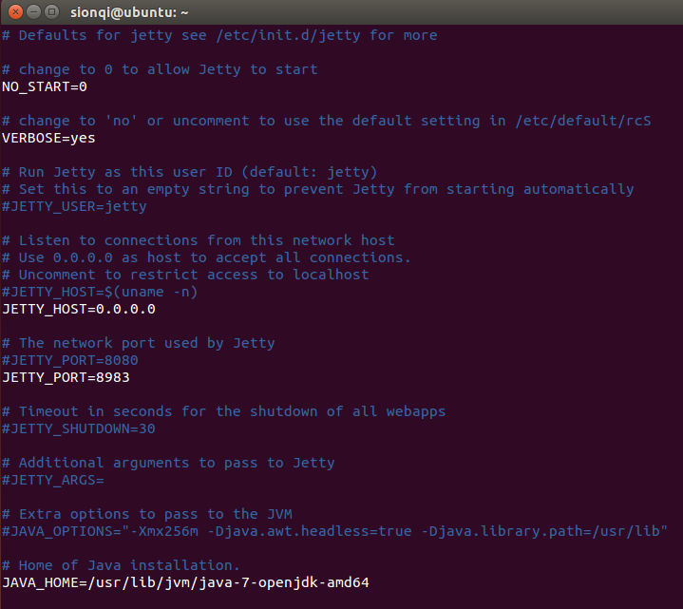

JDK Related

**Check JDK version**: java –version

**Options**: openjdk-6-jdk or openjdk-7-jdk

**Install command**: sudo apt-get install openjdk-7-jdk

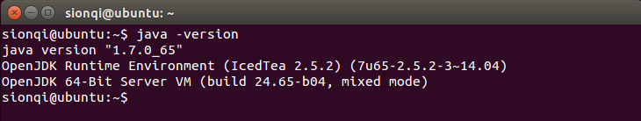

1. Replace the default schema.xml file with a symlink to the CKAN schema file included in the sources.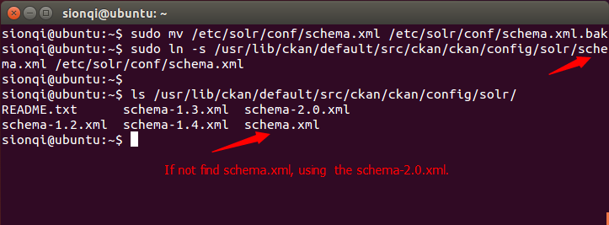
2. Restart Jetty

**Command**: sudo service jetty restart

**Open URL**: http:localhost:8983/solr

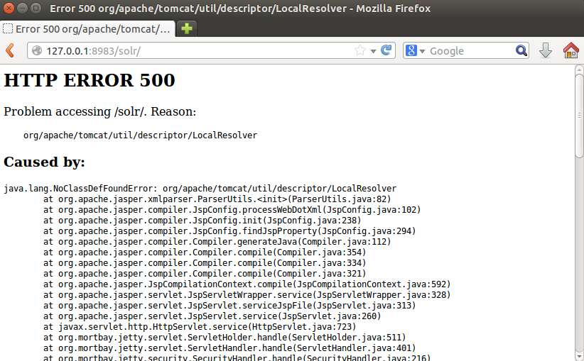

**The reason for the ERROR is missing a jar file. Check and get jar file:**

**Command**: ls /usr/share/tomcat6/lib/

**Or**: ls /usr/share/java

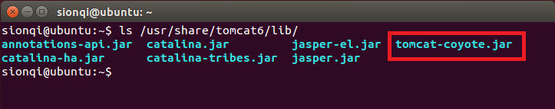

Edit Jetty start.config and add the jar file.

**Command**: sudo vi /etc/jetty/start.config

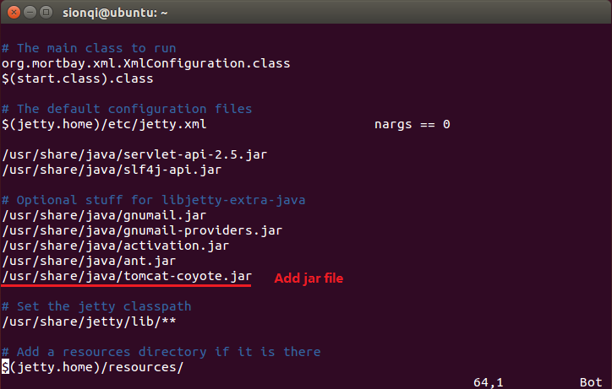

Now restart Jetty:

**Command**: Sudo service jetty restart

And check that Solr is running by opening <http://localhost:8983/solr>

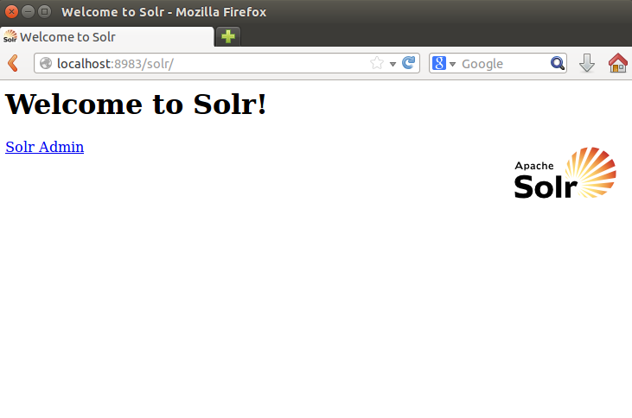

1. Finally, change the solr_url setting in your CKAN config file to point to your Solr server, for example:

**Command**: sudo vi /etc/ckan/default/development.ini

solr_url =http://127.0.0.1:8983/solr